**Date: 22-03-2025**

**INTERNSHIP LETTER**

This is to certify that **Mr. Gokarakonda Siri Teja** was working in our organization   
**Ozrit Ai Solutions** as **Python Developer Intern** from **20.01.2025 to 20.03.2025.**

We hereby certify that his performance was good during the tenure.

His contribution to the organization and its success will always be appreciated.

We wish him all the best in his future endeavors.

**For Ozrit Ai Solutions.**

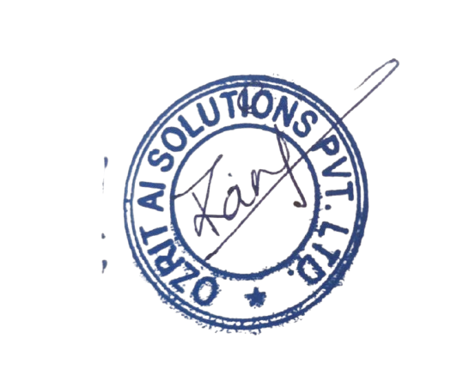

**Rani Kumari**

**HR & Admin Executive**